Registration Instructions
- Click on the “click here to register” button on the TQII website. Select “register as new user” under the login button.
- Enter your email and create a password. You will be asked to select a language. Please select the target language you are wanting to become certified in. An email will be sent to you to verify your account. You will also be asked to participate in a research study regarding the language proficiency testing. This study is voluntary. However, you must scroll down and check the box that states you are willing to participate in this study before you can move on to the next steps in registration. If you wish to not participate in this study, please email Xun Yan at xunyan@illinois.edu to state that you are not interested in participating once you have submitted your registration application.
- Once your email is verified, you will be prompted to log in.
- Once you log in, the screen will show you instructions for the TQII Language Test. Feel free to watch the video if you plan on taking the language proficiency test. Otherwise, please click on the “registration” button at the top righthand corner of the screen (highlighted in screenshot below)
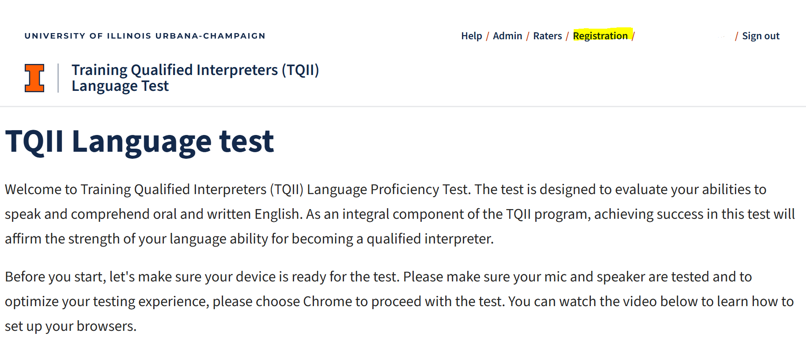
- You will be asked to enter your first and last name, IEIN (you MUST enter a valid number. Entering zero’s will result in your application being rejected), and native language. Click “update” once all information is entered.
- Scroll down to the bottom of the page to select the cohort which you are applying for.
  - Please note that seats are limited in each cohort. A message stating that seats are no longer available will show up once all seats have been taken.
- You will be asked if you need to take the language proficiency test for English. If you need to take the test: select the English Proficiency Test button. If you wish to exempt: select the “Do you want to request a English language proficiency testing exemption?” button and upload the exemption document. One you have made your selection, hit the “submit English proficiency request” button.
  - Please note that you can only upload one document. We will not accept any documents emailed to us.
- Next, you will be asked if you need to take the target language proficiency test. If you need to take the test: please select the Target Language Proficiency test button and indicate which language you want to become certified in. If you wish to exempt: select the “Do you want to request a foreign language proficiency testing exemption?” button and upload the exemption document. One you have made your selection, hit the “submit Target proficiency request” button.
- Finally, you will be asked if you would like to exempt out of the special education training. If you would like to exempt: please select the “Do you want to request a special education proficiency exemption?” button and upload your exemption document.
  - Please note that the ONLY exemption we offer for the special education training is if you have a special education endorsement on your license.
- Once all information is submitted, you will see this screen (screenshot below). This means that your application was received and our team will review it and make a final decision within 2-3 business days. You will not receive an email letting you know that your application was submitted.
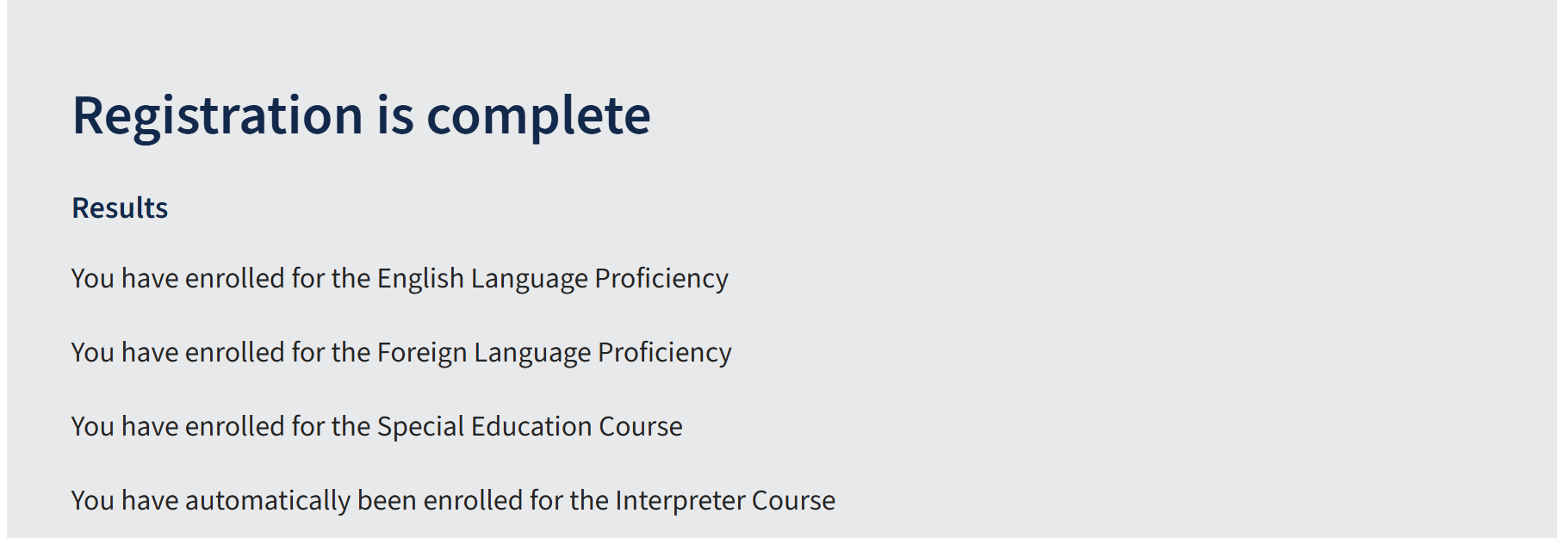
- Once we have reviewed your application, you will receive an email stating whether you have been approved or denied. If approved, the email will also contain all next steps and session information.

